SETTING UP APPLICATION ENVIRONMENT CREATE IBM CLOUD ACCOUNT

|  |  |
| --- | --- |
| **DATE** | **24 OCT 2022** |
| **TEAM ID** | **PNT2022TMID30749** |
| **PROJECT NAME** | **SKILL AND JOB RECOMMENDER**  **APPLICATION** |
| **TEAM MEMBERS:** | **Bavadharshini, Harishni, Madhumitha A,**  **Madhumitha K,**  **Monisha** |

# STEP 1:

Type or click the below link in the browser [***https://www.ibm.com/academic/home***](https://www.ibm.com/academic/home)

# STEP 2:

Click register icon and give all the details one by one,

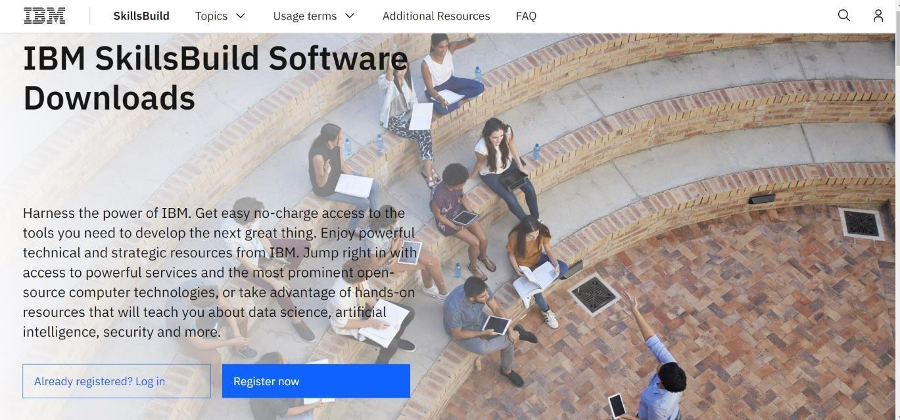

# STEP 3:

Already you got SI EMAIL and SI PASSWORD from your IBM student login. Login to your webmail account. Wait for 7-digit verification code in your web mail:

***https://sg2plmcpnl496936.prod.sin2.secureserver.net:2096/***

# STEP 4:

Get 7-digit verification code in webmail, then go to registration page and enter the verification code.

# STEP 5:

Now, you have successfully created the IBM Cloud Account.

# STEP 6:

Go to IBM Cloud login page: [***https: //cloud.ibm.com/login***](https://cloud.ibm.com/login) ,then enter your IBM Id and Password.

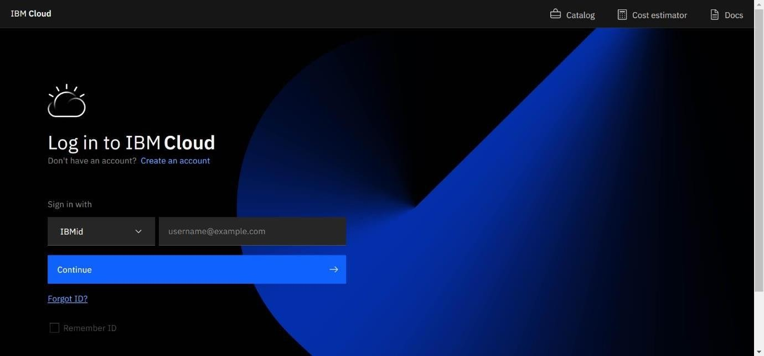

# STEP 7:

Finally, you will access the IBM cloud account.

